Windows Server Active Directory Lab

Documentation

Project 1: Windows Server Active Directory Lab
Prepared By: NASIR ALI
Date Completed: 30/10/2025

Project Summary
In this project, I built a virtual network environment using VirtualBox, simulating how a small business network operates. The setup included Windows Server and multiple Windows 10 client machines connected to a domain managed by Active Directory Domain Services (AD DS).
The main goal was to demonstrate how system administrators manage users, computers, and security policies within an enterprise environment. This included implementing DNS, Group Policy Objects (GPOs), and Folder Redirection, as well as applying Password, Account Lockout, and Auditing policies to harden the network.
Throughout the project, I created and tested several GPOs to manage settings across the domain, restricted access to the Control Panel, redirected user data to the server, and configured auditing to track failed login attempts using Event Viewer.
During setup, I also encountered and resolved multiple issues, such as network connectivity, DNS configuration, and time synchronization between virtual machines. Troubleshooting these problems helped reinforce real-world IT support and troubleshooting skills.
Overall, this project provided hands-on experience with domain management, user access control, security configuration, and system monitoring, key responsibilities in an IT Help Desk or System Administration role.

Introduction
In this project, I will simulate a small office network environment using VirtualBox.
I will create several Windows 10 virtual machines, each representing a user’s workstation. These machines will be connected to a domain managed by Active Directory, which provides centralised authentication, authorisation, and auditing services.
This setup will allow users to log in and securely access shared resources, closely replicating how a real-world business environment operates.
With each step, I will demonstrate secure design principles that align with CompTIA Security+ fundamentals.
I will also explain the security perspective behind each configuration decision, focusing on key areas such as access control, authentication, and policy enforcement.
Virtual Network Diagram
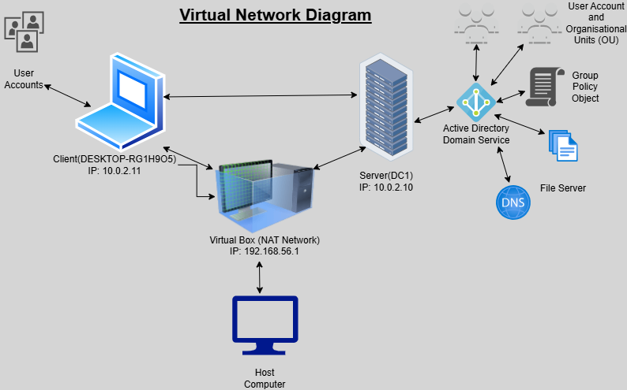
Figure 1: Virtual Network Diagram

Objective
- Set up multiple Windows 10 virtual machines and one Windows Server virtual machine using VirtualBox.
- Install Active Directory Domain Services (AD DS) and create a domain that all Windows 10 clients can join.
- Assign each machine a static IP address and verify connectivity using the PING command.
- Configure a local network that allows communication between all machines.
- Secure the environment by implementing authentication, access policies, and access control measures, aligning with the security principles of confidentiality, integrity, and availability (CIA).
- Apply Group Policy Objects (GPOs) across the domain to enforce system settings such as desktop backgrounds and configuration restrictions.
- Implement domain-wide password policies to strengthen authentication and harden the environment.
- Create shared folders and assign permissions to specific users and groups, testing access control from different accounts.
- Demonstrate account lockouts and password resets as part of user support procedures.
- Demonstrate monitoring and auditing by reviewing failed login attempts in Event Viewer.

Implementation/Steps

Network Setup

For the project, I wanted the clients and servers to be able to communicate with each other while also being able to connect to the host computer for external network access. VirtualBox provides several types of network adapters (NICs), and the one best suited for this setup is NAT Network, not the default NAT.

Both NAT and NAT network are options in VirtualBox, but I did not choose NAT because it does not allow communication between different nodes on the network, each node would only have direct access to the host computer. In contrast, a NAT network acts as a virtual router, placing all nodes on the same subnet so they can communicate with each other while still reaching external resources.

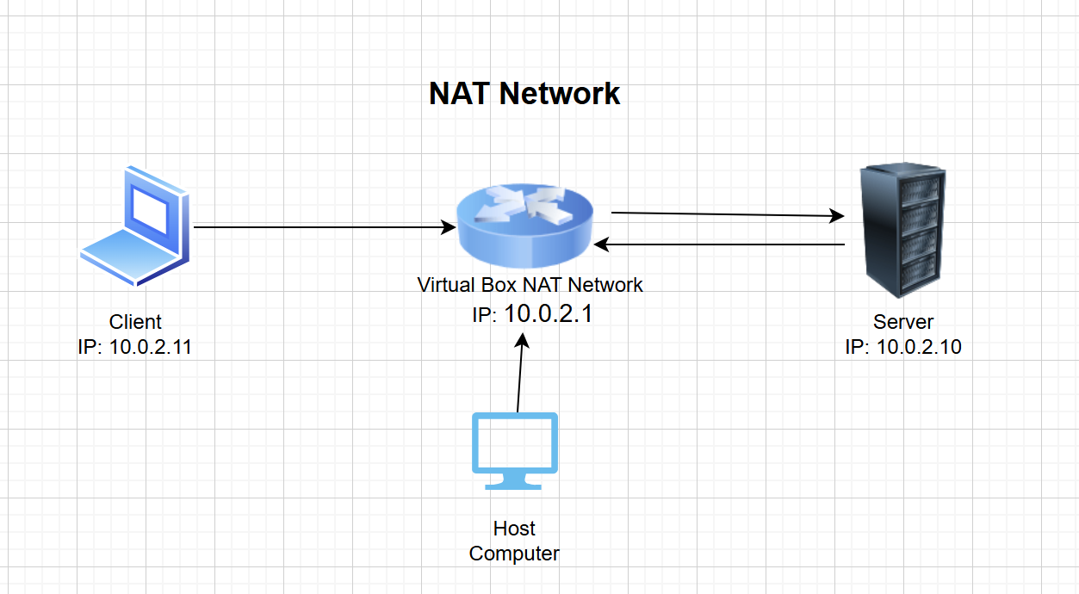

Figure 2: NAT Network Configuration

I created a network and named it LabNAT. VirtualBox automatically creates a virtual router inside the network, and each device’s NIC is configured to use NAT Network mode.

In the NAT network configuration, I have enabled DHCP so that each node on the network can automatically receive an IP address if needed. For this setup, all nodes currently have a static IP address. The server in particular has been assigned a static IP address to ensure it can always be found by other clients. For the client machines, whether they use static IPs or obtain their addresses via DHCP does not matter, as long as they remain in the same subnet.

The NAT Network router IP address is 10.0.2.1, which acts as the default gateway. DHCP can assign client IP addresses in the range 10.0.2.2 – 10.0.2.254, which provides more than enough addresses for my project.
(Continued)
Implementation – Network Setup

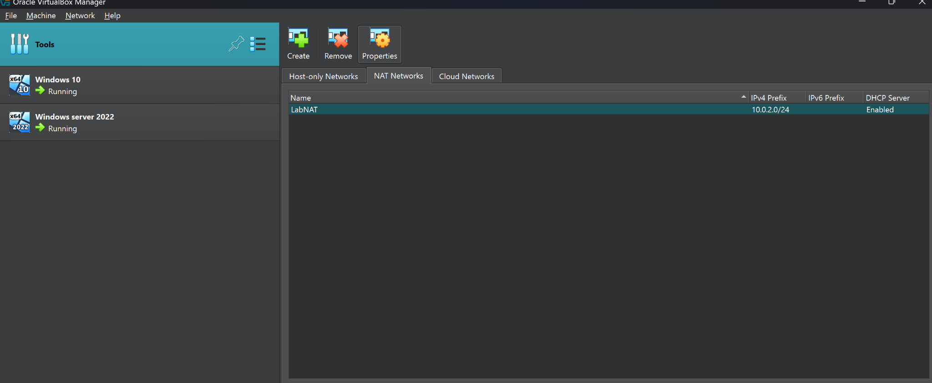

Figure 3: VirtualBox NAT Network Configuration
The NAT Network (LabNAT) was created to allow communication between the server and client machines within the 10.0.2.0/24 subnet.

Testing Connection
To verify connectivity between the client and server, I used the ping command to send ICMP echo requests to the server’s IP addresses (192.168.1.10).
The server replied to all four packets without any loss, confirming that it is reachable.
The low response time (1-14ms) indicates that both systems are on the same local network and are communicating successfully.
ICMP is often used in network troubleshooting but can also be exploited for reconnaissance in attacks like ICMP tunneling or ping sweeps. In secure environments, ICMP may be restricted through firewall rules to reduce exposure.
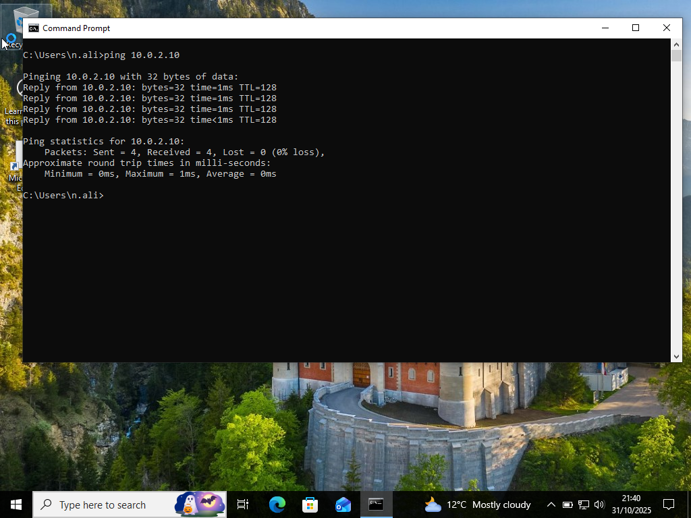

Figure 4: Testing Network Connectivity
The client (10.0.2.11) successfully communicates with the server (10.0.2.10) using the ping command, confirming that the NAT network is configured correctly.

Installing Active Directory Domain Services (AD DS)

To create a centralized directory system for managing users, passwords, emails, groups, and computers, I installed Active Directory Domain Services (AD DS) on the server.
Once installed, the server can be promoted to a Domain Controller, which runs AD DS and enables secure management of resources within the network. This allows both users and administrators to authenticate, access and manage systems from a single centralised environment.
AD DS enhances confidentiality and integrity by centralizing authentication and authorization. It uses Kerberos for secure logins and Group Policy to enforce security configurations across all domain-joined systems.
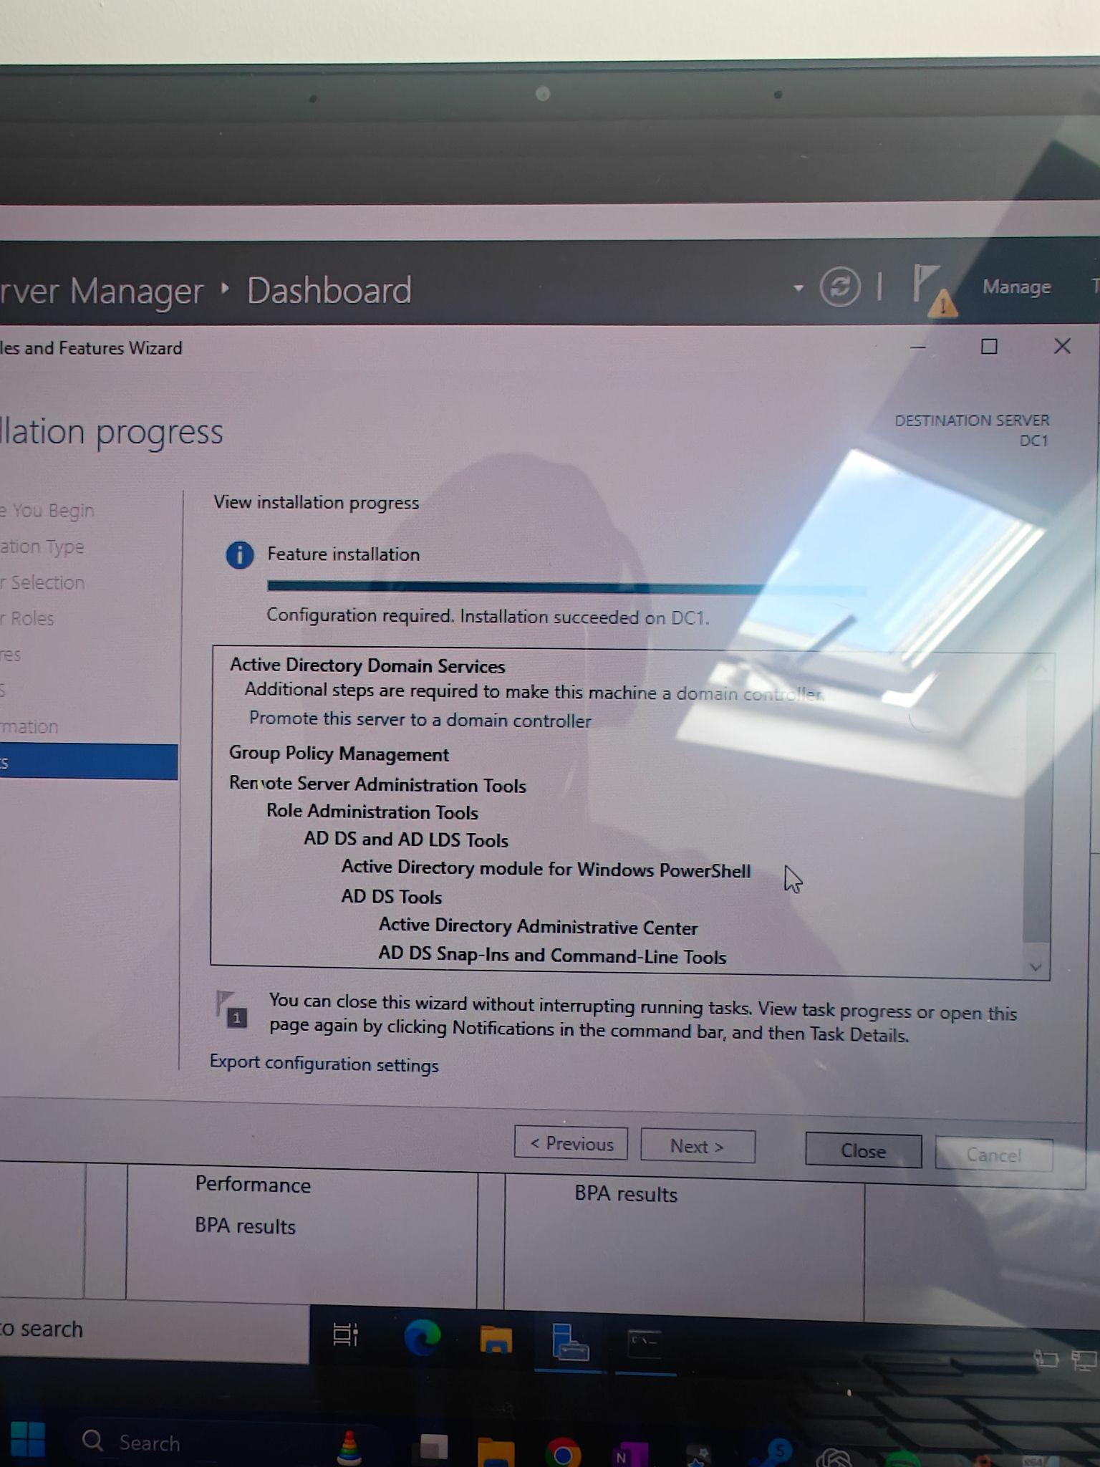

Figure 5: Active Directory Domain Services Installation
Active Directory Domain Services were successfully installed on the server (DC1), enabling centralized management of users, groups, and authentication across the domain.

DNS Configuration

DNS (Domain Name System), translates domain names into IP addresses, allowing web browsers and devices to locate and communicate with other systems on the network.
In this lab, I configured DNS on my Windows Server so that local devices can resolve names within the domain. To ensure consistent connectivity, I assigned a static IP address to both my Windows Server and Client machine.
Using a static IP is important in a server environment because it ensures the system’s address doesn’t change each time the network restarts – this makes it easier for clients to reliably locate the DNS server.
- Server IP address: 10.0.2.10
- Subnet Mask: 255.255.255.0
- Preferred DNS server: 10.0.2.10 (loopback to the local DNS service)
DNS is a critical network service, but it can also be a target for attacks such as DNS poisoning or spoofing. Securing DNS through access controls, logging, and DNSSEC (DNS Security Extensions) helps maintain data integrity and trust in name resolution.
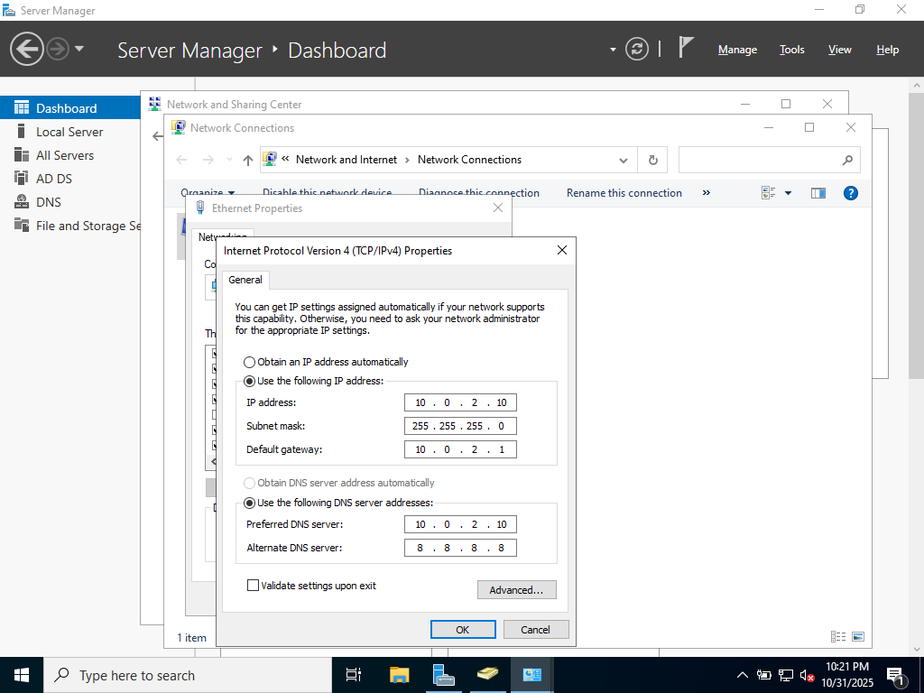

Figure 6: DNS Configuration
The DNS configuration was successfully set up, allowing the client to locate the server and enabling two-way name resolution within the network

Creating Users
To simulate a real-world office environment, I created multiple user accounts in Active Directory, each with a unique username and password.
Using Active Directory Users and Computers (ADUC), I navigated to my domain (Lab.local) and added new user accounts. I also created an Organisational Unit (OU) to group users logically, reflecting how accounts are typically structured in a business network for easier management and Group Policy application.
User accounts in Active Directory form the foundation of access control. By managing users centrally, administrators can apply the principle of least privilege and use Group Policy to enforce consistent security and access standards across the domain.

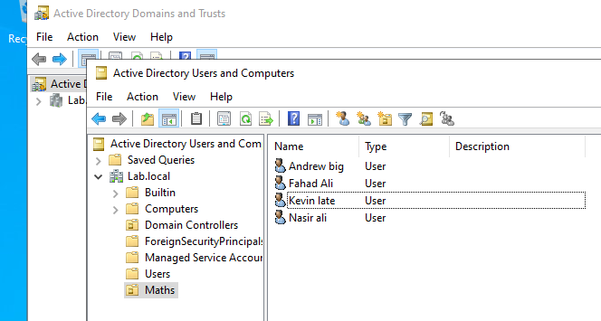

Figure 7: Active Directory Users and Computers (ADUC) – User and OU Creation
Multiple user accounts and organisational units (OUs) were created in the Lab.local domain to simulate a structured business environment.

Joining User Computers to the Domain Controller

By default, Windows computers are part of a WORKGROUP, meaning they operate independently and are not managed by a domain controller.
To allow centralised management and authentication through Active directory, each user computer must be joined to the same domain as the domain controller.
To do this, I changed the computer’s domain membership from WORKGROUP to Lab.local, enabling it to connect to and authenticate with the domain controller.
Joining computers to a domain strengthens authentication and access control, allowing administrators to enforce Group Policy and apply centralised security settings instead of relying on local user accounts.
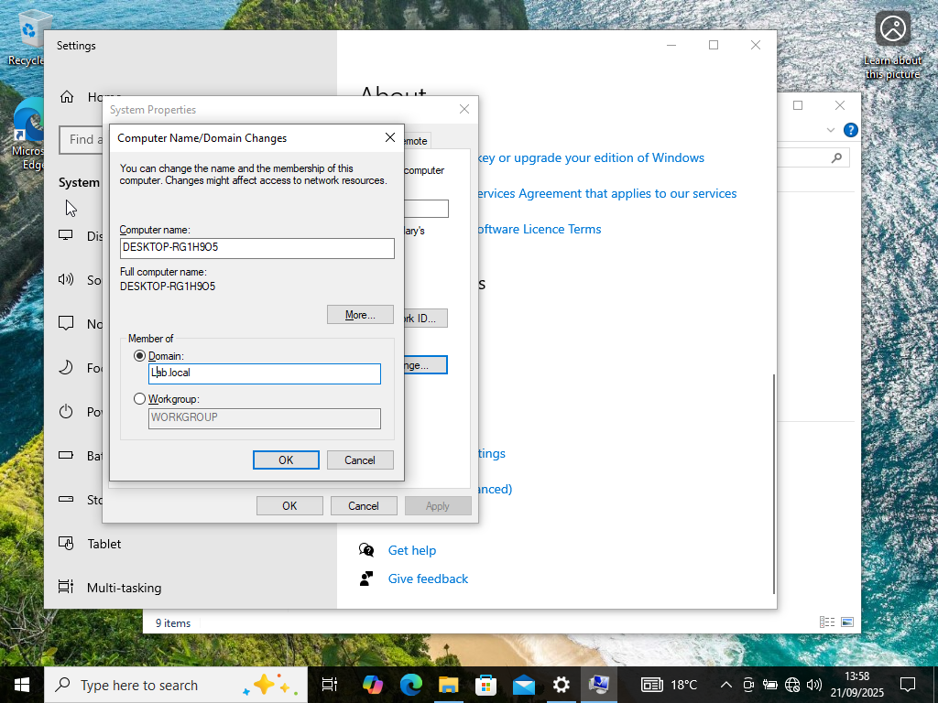
Figure 8: Joining Computer to the Domain Controller

The computer was successfully joined to the domain controller (Lab.local), enabling centralized management, authentication, and policy enforcement.

Blocked Access to Control Panel

The goal of this configuration was to restrict access to the Control Panel and PC Settings on client computers. To enforce this centrally, the following steps were taken:

A Group Policy Object (GPO) was created specifically to block access to the control panel for domain users.
(continued)
Implementation step - Blocked Access to Control Panel

- Opened Group Policy Management on the domain controller.
- Navigated to:
User Configuration - Policies - Administrative Templates - Control Panel.
- Enabled the policy: “Prohibit access to Control Panel and PC Settings.”
- Linked the GPO to the Maths Organisational Unit (OU) so it applied only to the intended users.
- Ran the command gpupdate /force on the Domain Controller to ensure the updated policy was rolled out across the network.
- Tested the policy by logging in with a domain user account on a client machine. When attempting to open the Control Panel, a restriction message appeared, confirming the policy was successfully applied.

By enforcing access restrictions on the Control Panel, I reduced potential attack vectors and minimised the risk of User misconfiguration.

This setup aligns with the principle of least privilege, ensures that only authorised administrators can modify system settings, helping to maintain system integrity and configuration control across the domain.

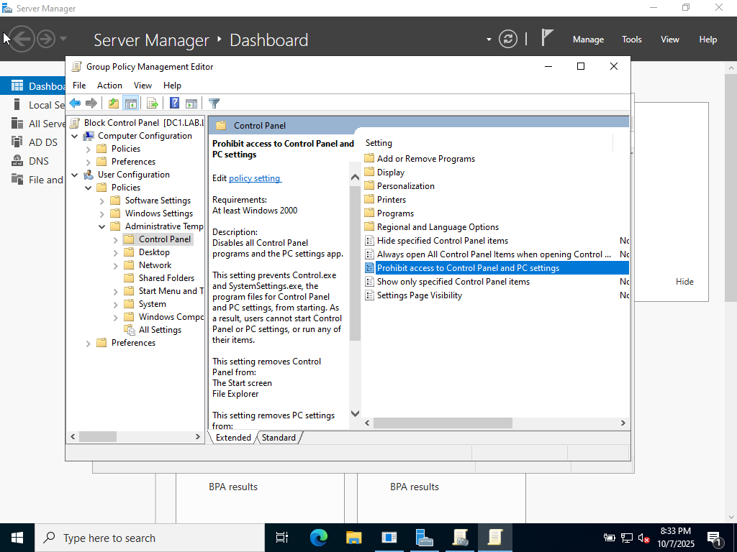

Figure 9: Control Panel Block for Domain Users
Access to the Control Panel was successfully blocked for domain users, preventing misuse and system misconfiguration.

Folder redirection

The goal is to centralise all users' domain files in a single, easily monitored location where policies and rules can be applied efficiently. To achieve this, I implement Folder Redirection using Group Policy in Active Directory.

Steps Taken:

- Created a group policy object (GPO) - Named it User Folder Redirection.
- Configured the GPO
- Navigated to:
User Configuration - Policies - Window Settings - Folder Redirection
- Selected "Created a folder for each user under the root path".

- Set the path to:
\\DC1\Redirected Users\%USERNAME%\Document
- Selected "Redirected everyone's folder to the same location”.

- Applied the GPO to the Maths OU, ensuring that all users within the OU have their files redirected to the server.

- Created a folder named Redirected Files on the server's C:\ Drive.
This serves as the destination where all user domain files will be stored.

Configuring permissions

Two types of access controls were configured:

- Advanced Sharing Permission - controls network access to the folder.
- NTFS Permissions - controls file-level access (read, write, modify).
NTFS permissions take precedence over sharing permissions.

Advance Sharing Permission

- Right-Click Redirected Files folder - Properties - Sharing - Advanced Sharing.
- Enable "Share this folder"
- Click Permissions.
- Add Everyone - Full Control.
  - This allows network access for all users.
  - The actual file-level access will still be controlled by NTFS permissions.
- Administrator, Creator Owner, and System retain full control.

NTFS Permissions
- Right-Click Redirected Files folder - Properties - Security - Advanced
- Disable inheritance.
- Remove all existing entries.
(Continued)
Implementation step - Folder Redirection

- Add Authenticated Users with the appropriate permissions (e.g. Modify, Read and Execute, List Folder Contents, Read, Write).
- Ensure Administrators, Creator Owner, and System have full control.

Folder Redirection ensures that user data is stored centrally on the server instead of locally on each workstation.
This setup improves data security, backup management, and policy enforcement across the domain.
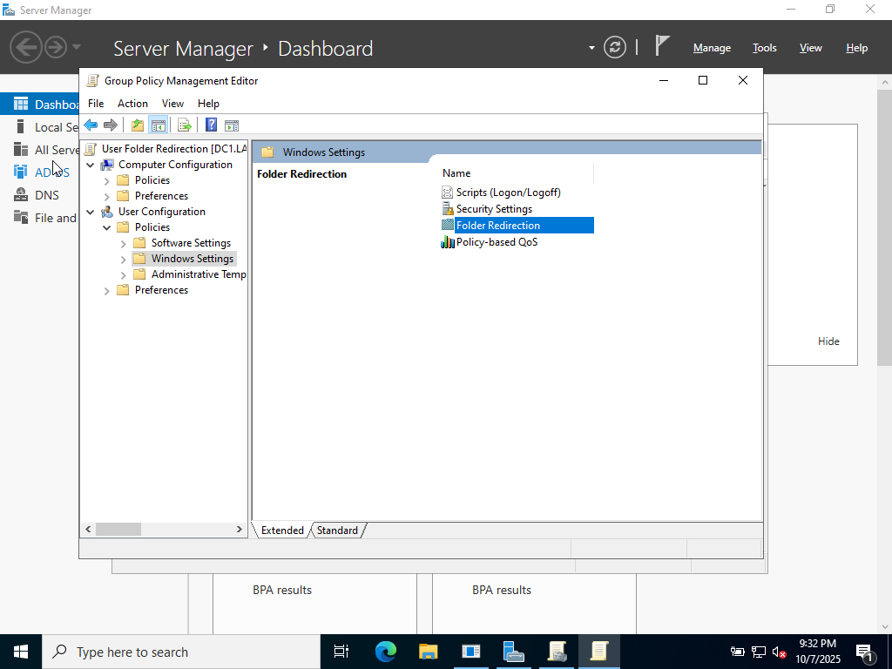

Figure 10: Domain User folders redirected to Server
User folders were successfully redirected to the server, allowing centralized management, backup, and access control.

Password Policy Configuration

The goal is to enforce strict password policy to reduce the risk of brute-force attacks. I implemented a domain-wide policy that enforces a minimum password length of eight characters and a password expiration period of 30 days.
This ensures that users regularly update their credentials and that short, weak passwords cannot be used.

Password Policy Configuration:
- Opened Group Policy Management
- Navigated to:

Default Domain Policy - Right-Click - Edit - Computer Configuration - Policies - Windows Settings - Security Settings - Account Policies - Password Policy
- Under Minimum password length, set the value to 8.
- Under Maximum password age, set the value to 30 days.
- Opened Command Prompt and ran: gpupdate /force to apply the updated Group Policy across the domain

Testing the Configuration:

To verify that the new policy was applied domain-wide, I ran the following command:
net accounts /domain

This displayed the current password policy, confirming the 8-character minimum and 30-day expiration period were successfully enforced.
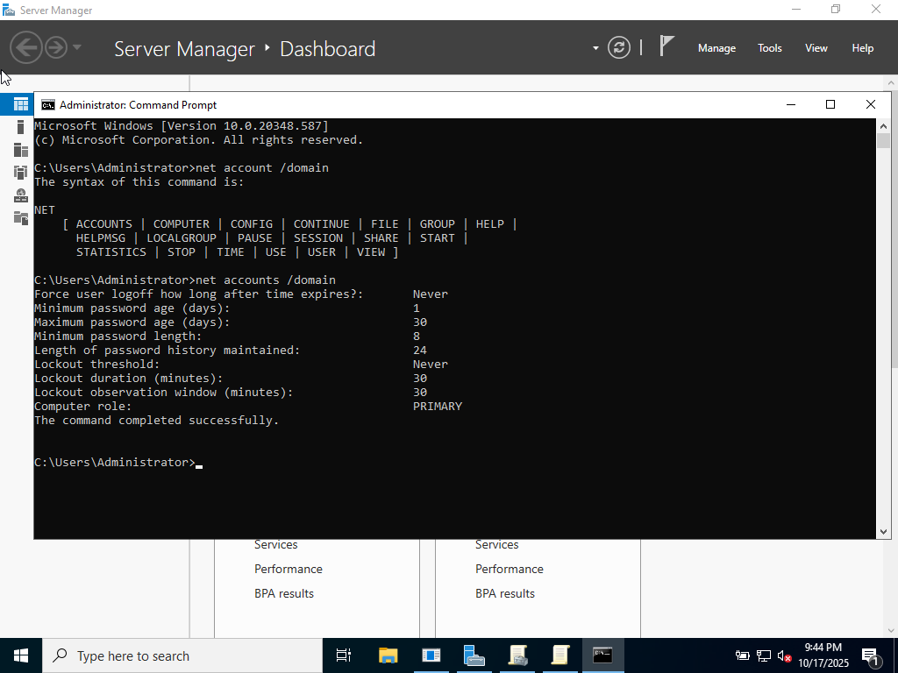

Figure 11: Password Policy Configuration
A domain-wide password policy was applied to all users to enforce strong authentication and reduce the risk of brute-force attacks.

(Continued)
Implementation step - Password Policy Configuration

Security

Implementing a strong password policy is the core of security best practice.
It protects against brute-force attack, reduces the risk of credential stuffing(where attackers reuse leaked passwords), and ensures that compromised passwords cannot remain active indefinitely.

By enforcing regular password changes, the domain maintains better control over authentication and access management, aligning with the Confidentiality, Integrity, and Availability (CIA) principles.

Account lockout and resets

The purpose of implementing account lockouts and password resets is to prevent unauthorized access and protect user accounts from brute-force or repeated login attempts. It also ensures that users update their passwords when necessary, such as after a potential compromise or to maintain overall account security and prevent misuse.

Objectives

- Create a Group Policy Object (GPO) that defines the account lockout policy.
- Configure an account lockout threshold to prevent brute-force attacks (e.g., locking the account after five failed attempts).
- Set a duration for how long locked accounts remain inaccessible before automatically unlocking.
- Configure the timer for when failed login attempts reset back to zero.
- Demonstrate account unlock and password reset procedures.
- Test and verify that the account lockout policy has been successfully applied on the client computer.

Implementation steps

- Create a new Group Policy Object (GPO) under the domain named "Account lockout Policy".
- Steps taken:
Computer Configuration - Policy - Window Setting - Security Setting - Account Policy - Account Lockout Policy
- Configured the Account Lockout Policy settings.
- Account lockout duration: 1 minutes
- Account lockout threshold: 5 invalid logon attempts
- Reset account lockout counter after: 1 minutes
- Update the Client and Server computer after applying the policy using Command Prompt.
- Steps taken:
- Open Command Prompt
- Enter the command: gpupdate /force
- Test and verify that the Account Lockout Policy has been successfully applied.
- Steps Taken:
- Entered incorrect password five times to trigger the lockout.
- Verified lockout settings using the command: Net Accounts
- Demonstrated account unlock and password reset.
- Steps taken:
Right-Click user - Properties - Account - Unlock account

Security connection

The most common way threat actors attempt to gain unauthorised access to systems is through brute-force attacks. By having an account threshold in place, it prevents repeated failed logins, reduces the risk of password guessing, and helps protect users' confidential data. If attackers were to gain entry, they could escalate privileges and move laterally across the network, potentially disrupting operations and causing serious damage to the organisation.
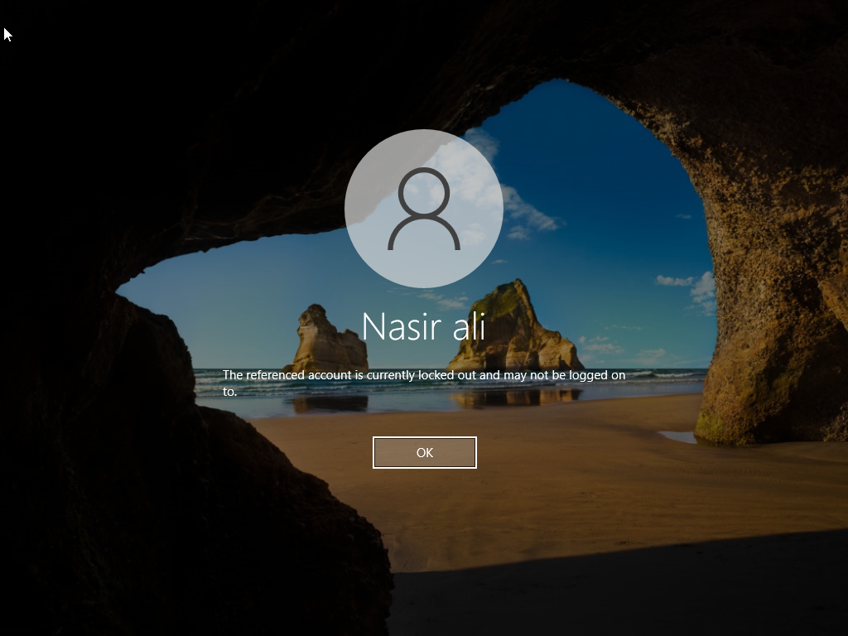
Figure 12 - Account Lockout and Reset Policy

The account lockout and reset policy was configured to disable accounts after multiple failed login attempts, reducing the risk of unauthorized access.

Logging and Monitoring

Account logging and monitoring are crucial for ensuring the network remains secure and that rules and policies are being followed. In this part of the project, I will enable auditing to track failed login attempts and account changes, and use Event Viewer to monitor and review logged events.

Objective

- Create a Group Policy Object (GPO) named Logging and Monitoring and apply it domain-wide.
- Test the policy by intentionally entering incorrect passwords and analysing the results in Event Viewer.

Implementation

- Create a new Group Policy Object (GPO) and name it Logging and Monitoring.
- Apply auditing settings to the GPO.

Steps taken:
- Navigated to:
Computer configuration - policies - Window Settings- Security Settings - Local Policies - Audit Policy
- Audit Account Logon Events: Success, failure
Purpose: Logs each time the Domain Controller verifies a user’s credentials (username and password).

- Audit Account Management: Success, failure
Purpose: Tracks any changes in Active Directory, such as when new users are added, accounts are deleted, or passwords are reset.

- Audit Logon Events: Success, failure
Purpose: Logs every instance when a user logs on or logs off a system.

Advance Settings

Advanced auditing breaks the basic categories into detailed sub-categories for more specific monitoring.

Options Selected:

- Audit Logons:
Purpose: Records each time a user logs in or logs out.
- Audit Other Logons/Failed Event:
Purpose:Captures Remote Desktop re-connections and VPN authentications.
- Audit Account Lockouts:
(Continued)
Implementation step - Logging and Monitoring

Purpose:Logs events when a user account becomes locked due to multiple failed login attempts.
- Under Account Logons - Audit Credential Validation:
Purpose:Logs incorrect password entries.
- Audit Credential Validation: Success and Failure
- Audit Kerberos Authentication Services: Success and Failure
Purpose: Logs when a user requests a ticket from the Domain Controller’s Key Distribution Center (KDC).
- Audit Kerberos Service Ticket Operations: Success and Failure
Purpose: Logs activity after the user has successfully logged in.
- Audit Logon (Under Logon): Success and Failure

- Test the auditing and monitor on Event Viewer

- After applying the GPO, sign in to a client computer and perform the following tests:
- Intentionally enter incorrect passwords multiple times to trigger failed logon events.
- Successfully log in afterward to generate success events.
- Open Event Viewer - Windows Logs - Security on the Domain Controller.
- Review event IDs such as:
  - 4771 – Failed logon attempt
  - 4624 – Successful logon
  - 4740 – Account locked out
- Confirm that the events are recorded correctly according to the configured audit policies.
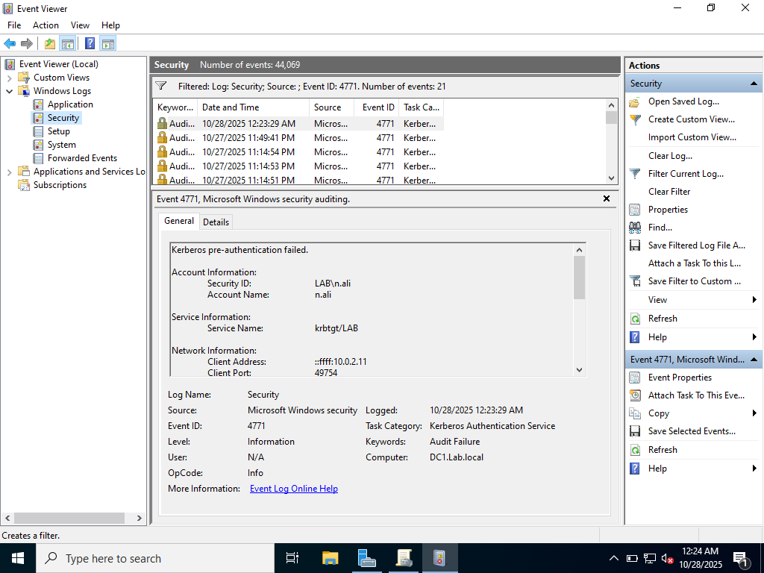

Figure 13: Logging and Monitoring Event Viewer
Event Viewer was used to monitor domain logon events, showing both successful and failed login attempts. This provides administrators with visibility into user activity and potential security incidents.
Problems Encountered & Solutions

Request Timed out
Issue:
When attempting to ping the Windows Server’s IP address, a “Request timed out” message was received.
Cause:
The Windows Firewall was blocking ICMP (ping) requests by default.
Solution:
Enabled ICMP Echo Requests in the Windows Firewall settings, which restored successful communication between the server and client systems.

Active Directory Domain Controller Could Not Be Contacted

Issue:
When attempting to join the client to the domain, the following error appeared:
“An Active Directory Domain Controller (AD DC) for the domain ‘Lab.local’ could not be contacted.”

Cause:
The client machine’s DNS configuration was incomplete — the DNS server field was left blank. Without the correct DNS entry, the client couldn’t locate the domain controller.

Solution:
I specified the Preferred DNS Server as the domain controller’s IP address (10.0.2.10).
After updating the DNS settings, the client was able to contact the domain controller and successfully join the domain.

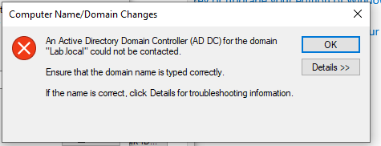
Figure 14: Active Directory Domain Controller Could Not Be Contacted Error
The client failed to locate the domain controller due to an incorrect DNS configuration. Updating the Preferred DNS Server to the domain controller’s IP address resolved the issue.

Internet connectivity issues

Issue:
When configuring both the client and server to access the internet via a NAT network, neither could reach external addresses.
Pinging 8.8.8.8 from either machine failed, confirming that packets were leaving but no replies were received.
Investigation steps:
- Verified Windows Firewall wasn’t blocking ICMP.
- Checked for multiple network adapters (NICs) that could cause conflicts.
- Confirmed both VMs were attached to the same NAT Network in VirtualBox.
- Verified the IP configuration on the server.
Findings:
The server’s IP configuration did not correctly point to the NAT router (10.0.2.1) as its default gateway.
After correcting the gateway, connectivity still failed. Running route print showed multiple default gateways, including a 0.0.0.0 ghost entry alongside 10.0.2.1, which caused routing conflicts.
Solution:
- Cleared the routing table and deleted stale default routes.
- Added a single, persistent default route to 10.0.2.1.
- Verified successful connectivity using ping 8.8.8.8.
Lesson learned:
- Duplicate or stale default gateways can break internet access in Windows Server.
- Always check ipconfig /all and route print when troubleshooting connectivity issues.
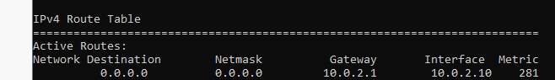
Figure 15: IPv4 Route Table Showing Incorrect Default Gateway
The route table displayed duplicate default gateways (0.0.0.0 and 10.0.2.1), causing routing conflicts. Removing stale routes and adding a single persistent default route restored connectivity.
Time Synchronization Issue

During the setup process, I encountered issues with incorrect system time and synchronization between the Domain Controller and Client VM. This caused authentication and auditing logs to display inaccurate timestamps.

Steps taken:

- Verified time synchronization from the client:
  - On the client machine (running as Administrator), I ran the following command:
W32tm /resync
  - Observed that both the server and client displayed incorrect time and date
  - Verified the current time using
time and Get-Date
- After running the command, I noticed that both the server and client had incorrect time and date.
  - Verified using the commands:
Time
Get-Date
- Checked Windows Time Service on the Domain Controller
  - Opened Server Manager - Tools - Services - Windows Time and ensured it was set to Automatic.
  - Although it was set correctly, the time remained wrong.
- Attempted to Change Time from the Client Machine
  - Navigated to Settings - Time & Language - Date and Time.
  - Automatic time settings were unavailable with the message:
“Some of these settings are hidden or managed by your organisation.”
- Identified Time Zone Mismatch
  - The client showed 2:40, while the server showed 7:40.
  - Determined that this was due to a time zone mismatch between the two systems.
- Changed the Time Zone on the Server
  - Opened Control Panel - Date and Time - Change Time Zone.
  - Set the time zone to (UTC+00:00) London.
  - The time was still incorrect after these changes.
- Checked VirtualBox Time Synchronization Settings
  - Verified that the host computer provides time synchronization.
  - Noted that VirtualBox Guest Additions must be installed and time sync enabled for accurate synchronization.

(Continued)
Problems Encountered & Solutions- Time Synchronization Issue
Resolution:
Installed VirtualBox Guest Additions, rebooted both systems, and verified that the client and server times were synchronized correctly.
Lesson Learned:
Time synchronization is critical in Active Directory environments to prevent Kerberos authentication errors and ensure accurate event logging.

Conclusion
In conclusion, I have successfully set up a virtualized network environment using VirtualBox, running both Windows Server and Windows Client machines. Through these virtual machines, I was able to simulate a real-world office environment consisting of Active Directory Domain Services (AD DS), Organizational Units (OUs), Group Policy Objects (GPOs), Users, and Groups.
By configuring DNS and implementing security policies, I established seamless communication between the client and server. This project has strengthened my understanding of how enterprise networks operate, how administrators manage user access and security, and how policies can be applied to maintain compliance and control within an organization.

